Werkblad:

1. Zang: Wie zingt er? Hoe klinkt de stem?

Hoog/laag, warm/koud, licht/donker, jong/oud

1. Welke instrumenten hoor je?
2. Vormschema (in stukjes A/B/C/D of refreinen tellen)
3. Waar gaat de tekst over?

Antwoorden werkblad:

1. George Ezra, man, laag/bas, Engels, warm, donker, jong of oud, achtergrondkoor

2. elektrische gitaar, drums, basgitaar, shaker, blazers waaronder trompetten, tamboerijn, etc.

3. intro – A – B – C – A – B – C – A – B – C – C of het refrein komt vier keer voor

4. de tekst gaat over iemand die op vakantie is 🡪 gotta hit the road, architecture unfamiliar, riding shotgun = naast de bestuurder in de auto zitten

Tekst Shotgun:

INTRO

Homegrown alligator, see you later  
Gotta hit the road, gotta hit the road  
Something changed in the atmosphere  
Architecture unfamiliar   
I can get used to this

Time flies by in the yellow and green  
Stick around and you'll see what I mean  
There's a mountaintop that I'm dreaming of  
If you need me you know where I'll be

**I'll be riding shotgun underneath the hot sun  
Feeling like a someone  
I'll be riding shotgun underneath the hot sun  
Feeling like a someone**

The south of the equator, navigator  
Gotta hit the road, gotta hit the road  
Deep-sea diving 'round the clock,

bikini bottoms, lager tops  
I could get used to this

Time flies by in the yellow and green  
Stick around and you'll see what I mean  
There's a mountaintop that I'm dreaming of  
If you need me you know where I'll be

**I'll be riding shotgun underneath the hot sun  
Feeling like a someone  
I'll be riding shotgun underneath the hot sun  
Feeling like a someone**

We got two in the front  
Two in the back  
Sailing along  
And we don't look back…

Time flies by in the yellow and green  
Stick around and you'll see what I mean  
There's a mountaintop that I'm dreaming of  
If you need me you know where I'll be

**I'll be riding shotgun underneath the hot sun  
Feeling like a someone  
I'll be riding shotgun underneath the hot sun  
Feeling like a someone**

2x

Plaatjes:

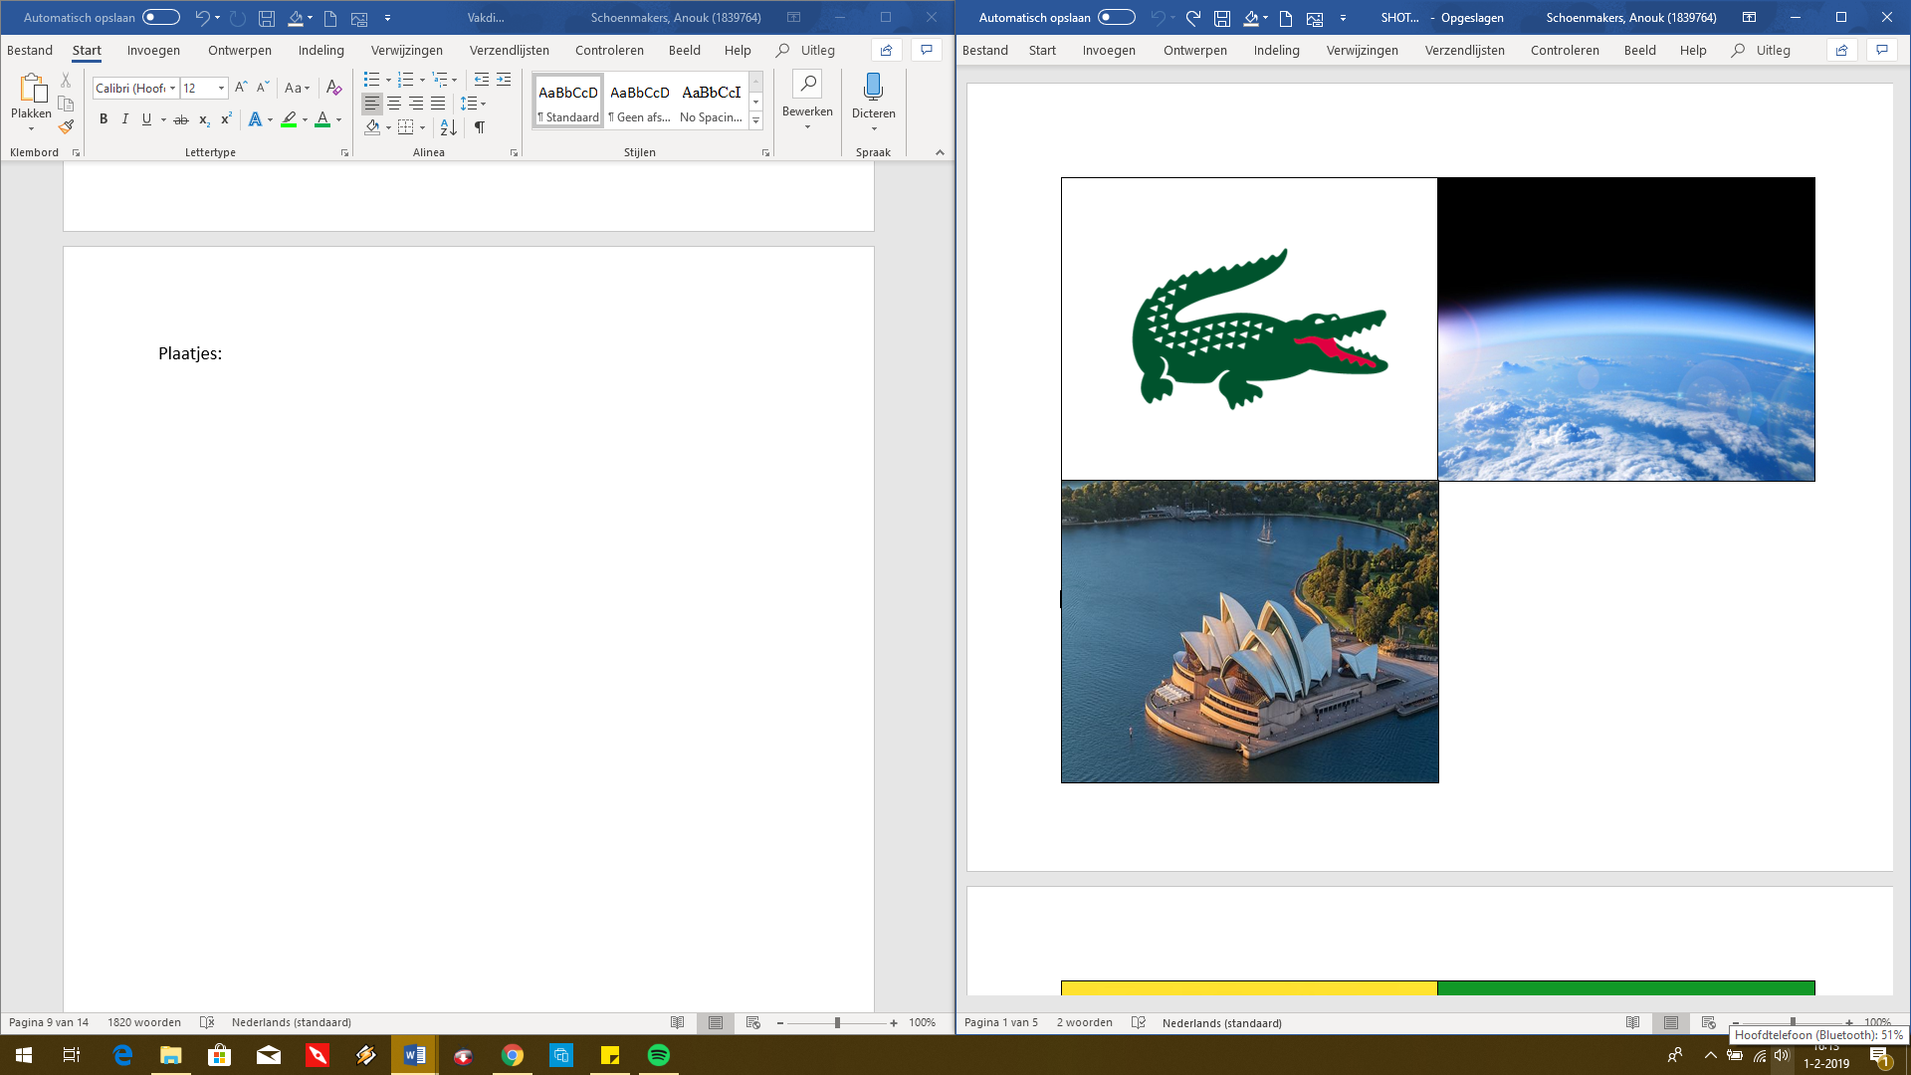

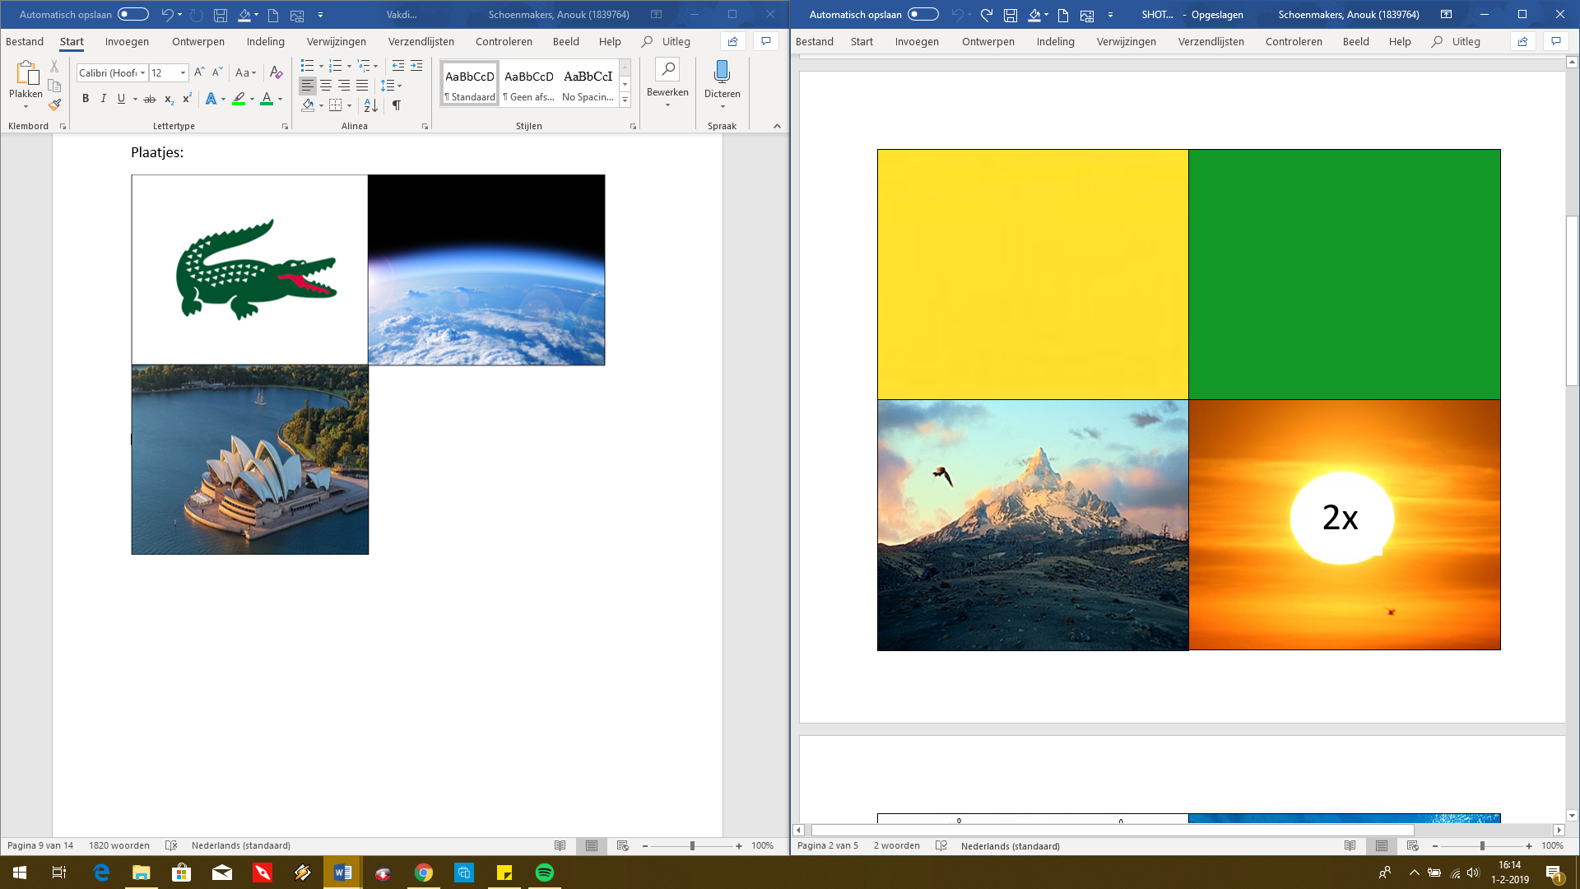

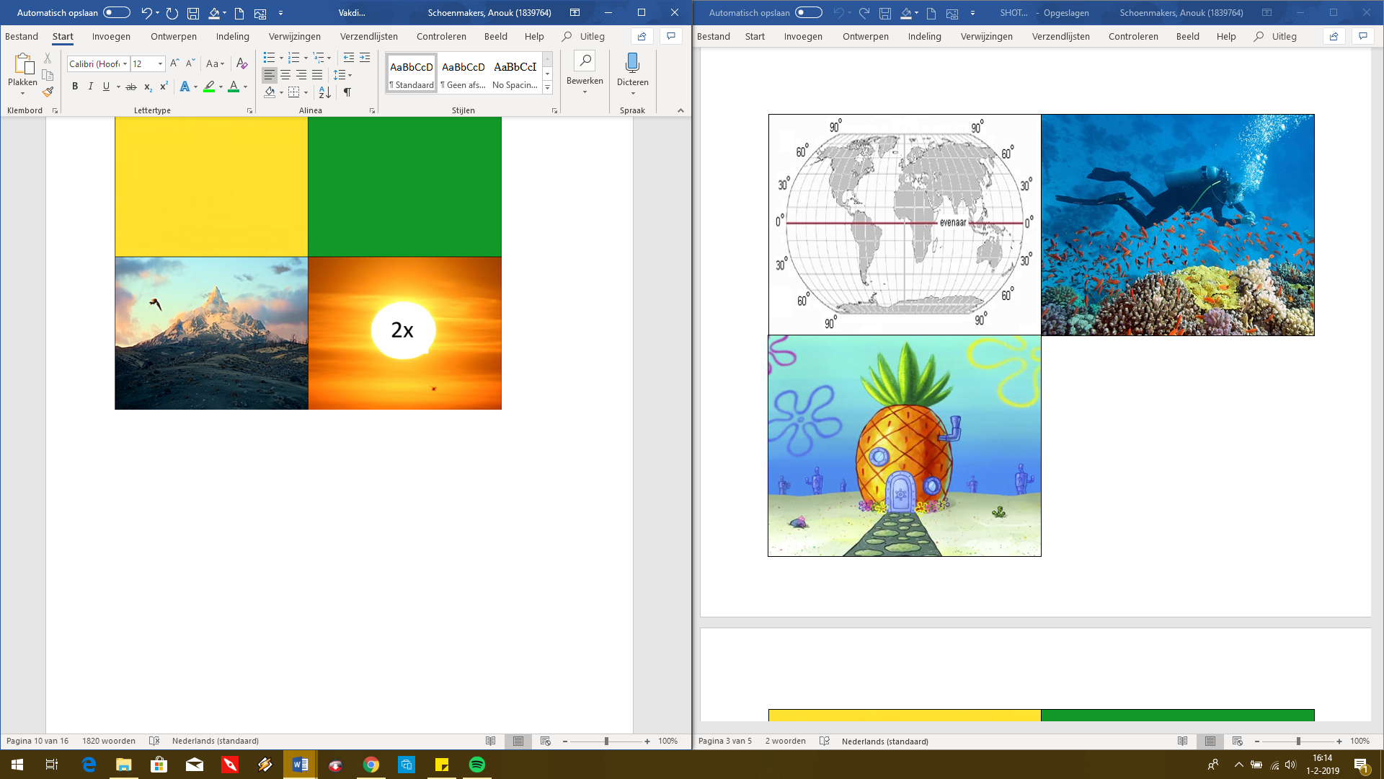



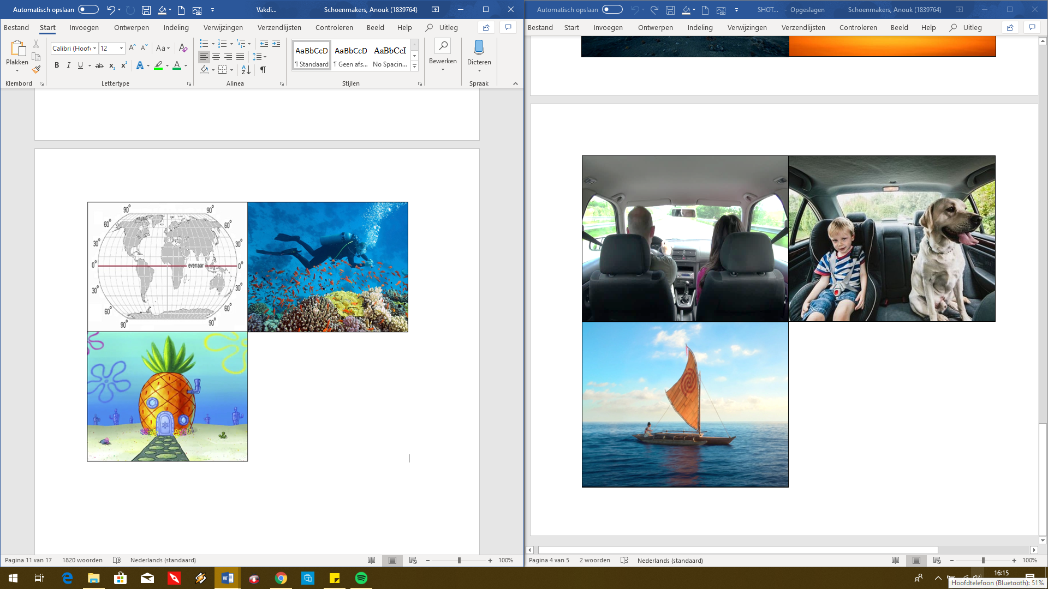

PowerPoint:

